**Software Requirements Specification**

**For**

**Apple Watch Health Monitor App**

**Version 1.0**

**Prepared by Logan McCarthy**

**Department of Computer Science, LaTech**

**Nov 2, 2020**

**Contents**

1. **Introduction**
   1. **History**
   2. **Statement of the Problem**
   3. **Purpose**
   4. **Product Scope**
2. **Overall Description**
   1. **Product Perspective**
   2. **Product Functions**
   3. **User Classes and Characteristics**
   4. **Operating Environment**
   5. **Design and Implementation Constraints**
   6. **User Documentation**
   7. **Assumptions and Dependencies**
3. **Use Case and Interface Requirements**
   1. **Use Case Diagram**
   2. **Watch Application API**
   3. **User Interphase (Rough Sketch)**

**1. Introduction:**

**Cryopreservation** is a highly speculative procedure applied to legally deceased individuals in the hope of future revival. Cryopreservation involves mechanical chest compression, administration of metabolic suppressing drugs, and reduction of patient body temperature to just above the freezing point of water as rapidly as possible following cardiac arrest. Typically, the patient’s blood is then replaced with an organ preservation fluid. The patient is shipped by air to his or her cryonics organization where the organ preservation fluid is replaced with cryoprotectants, followed by slow reduction of the patient’s temperature through the sub-zero range until the patient’s body vitrifies (as opposed to freezing). The patient is then placed into long term storage in liquid nitrogen. The sub-zero phases of the cryopreservation procedure are non-reversible with current technology.

**1.1 History**

Most medical professionals and relevant research scientists consider **cryonics** (the development and application of cryopreservation procedures to legally deceased individuals) to be a pseudo-science with essentially no chance of success. [REFS] A minority of academics consider cryonics to be a potentially life-saving technology that halts metabolic decay, and (under optimal conditions) preserves sufficient memory and personality critical information, to allow for the possibility of advanced technology (e.g., nanotechnology) to enable revival at some point in the future. [REFS]

Alcor is a 501c3 non-profit focused on the development and implementation of cryonics procedures for its members. In 2020, an Alcor member experienced unattended cardiac arrest in his home and his body was not discover for many days. As an Alcor member this individual desired to be cryopreserved immediately following his legal death. Clearly, multiple days (potentially weeks) of post arrest warm ischemia is incompatible with preservation of identity critical information (e.g., detailed neural anatomy / connectome).

**1.2 Statement of the Problem:**

Regardless of one’s view of the likelihood of success of cryonics in general, all would agree that multiple days or weeks of warn ischemia and biological decay clearly destroy brain tissue and the connectome it contains, thus eliminating any chance for the preservation of memory and personality information. Thus, for a cryonicist, minimizing post arrest ischemic delay is of critical importance.

Additionally, non-cryoncists are often quite disturbed by the thought of a loved one experiencing unattended cardiac arrest in their home and not being found until days or weeks later. Unfortunately, as more and more elderly Americans live alone, death under these circumstances is no longer a rare occurrence.

The problem we face is that current technology can monitor and record bioinformatic data, but devices do not use this data to implement preventative measures for hazardous and possible life-threatening events with the exception of fall detection.

**1.2 Purpose**

What we propose is the implementation of an application that utilizes the pre-existing sensors and technology within Apple Watch and other smart watches to monitor the wearer’s vitals and bioinformatics. When potentially irregular activity is detected, the device could then generate and transmit SMS messages to a contact list to alert relevant individuals.

**1.3 Product Scope**

Such an application would offer a chance for paramedics and life-saving procedures to be deployed before these biological irregularities claim the life of the patient.

In the case that life-saving procedures cannot be employed, the smart watch app could at least ensure that the deceased’s loved ones were notified of his / her passing without delay. For cryonicists, such an application could allow for more prompt application of cryonics stabilization procedures, without the patient experiencing many hours (days or weeks) of post-arrest ischemic delay.

**2. Overall Description:**

**2.1 Product Perspective**

The Apple Watch Health Monitoring App is a novel idea that originates in the need for faster response times to cardiac arrest patients outside of the hospital setting. The current apple watch and like wise products do not utilize the sensor technology in the watch for medical application and actual medical device are crude, bulky, and inconvenient.

**2.2 Product Function**

The Apple Watch Health Monitoring App utilizes the technology that comes with most smart watches and smart devices like the accelerometer and the light‑sensitive photodiode optical heart sensors. The functions include:

* Detection of the watch being worn
* Detection of heart rate readings
* Medical data analysis
* SOS contact
* Provide quick response auxiliary application
* *Check Fall detection (if necessary???)

**2.3 Operating Environment**

The app operates on the Apple Watch Series 4. The Apple Watch Series 4 (GPS + Cellular) requires an iPhone 6 or later with iOS 12 or later. Apple Watch Series 4 (GPS) requires an iPhone 5s or later with iOS 12 or later.

From the developer perspective, the software is developed and simulated on Xcode via a Mac. The project utilizes the standard project director (proj4) as well as the project WatchKit Extension directory (proj4 WatchKit Extension). The standard proj4 ContentView.swift file contains all of the Iphone code while the ContentView.swift file in the proj4 WatchKit Extension directory handles all the main functions of the watch side of the app. A mailgun bridge.m file is added to send SOS messages when flag is triggered and a proj4-Bridging-Header.h allows objective C code to be included in swift code.

**2.4 Design and Implementation Constraints**

**Design Requirements**

Apple Smart Watch with:

* Light‑sensitive photodiode optical heart sensors
* Black Crystal electrodes
* Wifi and/or cellular capability
* GPS
* Accelerometer and Gyroscope
* Mac or Mac VM to develop Apple Watch app

Technical requirements:

* Knowledgeable personnel in apple technology and app development
* Software for coding in Mac operating environment (xcode)(react??)
* Licensing and/or legal requirements to distribute application

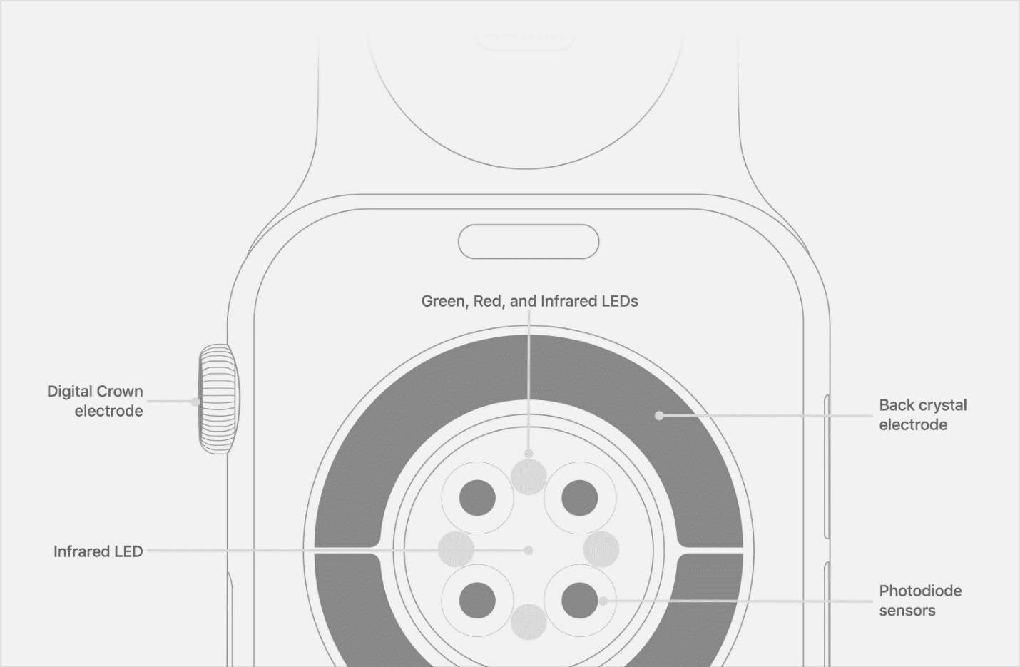

**Figure ___:** Apple Watch Bottom-Outside Sensors.

**Wearer Detection**

The watch detects being worn by using built-in electrodes in the back of Apple Watch, which can measure the electrical signals across your heart when used with the Heart Rate app or the ECG app. When you place your finger on the Digital Crown, it creates a closed circuit between your heart and both arms, capturing the electrical impulses across your chest. As an additional feature, this can be used for detailed readings of the heart rate.

Through accessing the black crystal electrodes, the watch will actively listen for bioelectric static every ___ seconds to determine if it is being worn. In the case that it isn’t being worn, it will prevent conditions considered outside the normal healthy range from triggering (ie. prevent a lack of heart rate due to not being worn from sending SOS).

**How the Electrical Heart Sensors work**

To use the electrical heart sensor to measure your heart rate, open the Heart Rate app and place your finger on the Digital Crown. You will get a faster reading with higher fidelity — getting a measurement every second instead of every 5 seconds. You’ll see "ECG" in Heart Rate Context when looking at recorded data for Heart Rate in the Health app. You can also use the electrical heart sensor to take an ECG with the ECG app.

**Heart Rate Detection**

The watch detects heart rate by using photoplethysmography to measure light reflecting from your skin through the use of the Apple Watch’s Green, Red, and Infrared LED optical heart sensors. The watch runs these readings in comparison with the medical information/data stored within the Medical Data App to determine safe conditions.

In the case that the heart rate detection determines that the hear rate is to low or to high or if the heart rate is erratic per second over the course of 10 seconds), a prompt with a message and timer will be sent to the wearer requesting there health conditions. If a “SAFE” condition is not given within the elated time of the timer (Default 30 sec), an additional audible prompt will be triggered with anther timer Default 30 sec). If a “SAFE” condition is still not given, the emergency SOS will be triggers and a SOS message with the time and location will be sent to all emergency contacts.

As a secondary use of the gyroscope and the accelerometer as inactive suppression where they can be used to reset any triggers or timers for abnormal heart rates. This is because, if the gyroscope and accelerometer steady, non-sudden movement and the watch is be read as “worn”, a “SAFE” condition can be assumed since the person must be moving and not on the ground due to a medical emergency.

**How the Blood Oxygen app works**

In Apple Watch Series 6, the optical heart sensor has been redesigned to add blood oxygen measurement capabilities. During a blood oxygen measurement, the back crystal shines red and green LEDs and infrared light onto your wrist. Photodiodes then measure the amount of light reflected back. Advanced algorithms use this data to calculate the color of your blood. The color determines your blood oxygen level — bright red blood has more oxygen, while dark red blood has less.

The optical heart sensor supports a range of 30–210 beats per minute. In addition, the optical heart sensor is designed to compensate for low signal levels by increasing both LED brightness and sampling rate.

To use the electrical heart sensor to measure your heart rate, open the Heart Rate app and place your finger on the Digital Crown. You will get a faster reading with higher fidelity — getting a measurement every second instead of every 5 seconds. You’ll see "ECG" in Heart Rate Context when looking at recorded data for Heart Rate in the Health app. You can also use the electrical heart sensor to take an ECG with the ECG app.

**Outgoing SOS**

The watch is able to send out an SOS to emergency contacts during unsafe condition through Mailgun and GoDaddy. The emergency message generated and sent via email by the Mailgun feature built into Apples OS. A GoDaddy server receives this email and generates and SMS version of the email to forward to all emergency contacts designated within the Apple Watch Health Monitoring App.

In the case that the SOS is sent out, the Apple Watch Health Monitoring App will access the watch’s GPS as well as its clock in order to attached this to the outgoing SMS message.

**Quick Response Application**

In the case of emergencies, an auxiliary application will be added in conjunction with the main application on the home screen. When this app is pressed or activated, it will generate a timer that, if not terminated, will send out the outgoing SOS regardless of heart rate or medical conditions. To terminate the signal, the user must press and hold the “SAFE” button until alert is terminated (2-3 seconds).

Much like the Heart Rate Detection, in the case that the emergency auxiliary application is pressed or activated, a prompt with a message and timer will be sent to the wearer requesting their health conditions. If a “SAFE” condition is not given within the elated time of the timer (Default 30 sec), an additional audible prompt will be triggered with anther timer Default 30 sec). If a “SAFE” condition is still not given, the emergency SOS will be triggers and a SOS message with the time and location will be sent to all emergency contacts.

**Fall Detection**

It is unsure if this is a necessary application as it is already implemented in Apple Watches. In the case that it is, it will utilize the watches gyroscope and accelerometer via the Core Motion library built into the Apple OS. When triggered, the app will send out a message with a timer awaiting the wearers verification that they are ok. If the timer isn’t terminated, it will access the outgoing SOS just as the previous features do.

**How the Fall Detection Works**

A fall is the condition when the total acceleration applied on the object equals the value of acceleration of gravity. We now know the accelerometer that provides Apple Watch the acceleration by which the device moves along the linear path. So, we will use this value to detect a fall in device.

* 1. **Design Documentation**
* Accessing the watch via Xcode – watchkit and the WatchKit Extension
  + <https://developer.apple.com/documentation/watchkit>
  + <https://developer.apple.com/watchos/>
  + <https://www.apple.com/healthcare/apple-watch/>
* Accessing Heart Rate sensors – HealthKitHeartRateExplorter
  + <https://developer.apple.com/documentation/healthkit/about_the_healthkit_framework>
  + <https://github.com/BradLarson/HealthKitHeartRateExporter>
* Accessing GPS – locationManager
  + <https://www.spaceotechnologies.com/build-apple-watch-app-watchkit-tutorial/>
* Accessing Apple Watch Gyroscope & accelerometer – Core motion ([CMMotionManager](https://developer.apple.com/documentation/coremotion/cmmotionmanager))
  + Use a CMMotionManager object to start the services that report movement detected by the device's onboard sensors
  + <https://developer.apple.com/documentation/coremotion> .
  1. **User Documentation**

**<Still need input here. Don’t know until I know UI interface and how code will prompt the user.>**

**2.7 Assumptions and Dependencies**

**Wearer Detectability via Black Crystal electrodes**

The first assumption that needs testing is that we will be able to determine if the watch is being worn via the black crystal electrodes. The assumption is that there will be a distinct change is conduction and resistance from the electrodes when pressed against the skin rather than being open to air and non-organic material.

This assumption is vital because other applications use the optical light sensors to detect if being worn but these are currently being used to determine heart rate. If these optical sensors were to be used in this manner, there would be little to no know way of determining the difference between the watch not being worn and cardiac arrest.

**Accurate Heart Rate via Optical Sensors**

The second assumption that needs to be tested is if the optical sensors can yield an acceptable number of true negative and true positives without yielding and large number of false negatives and/or false positives. We projecting an acceptable rate for this non-FDA application to be an 85% accuracy (Changeable to whatever Dr. O’Neal would prefer).

**Ability to Send SMS Text**

The third assumption is that we will be able to automatically send a text message to an SOS contact list. While the text message may or may not be vital to the operation of the application, some form of outgoing message is, whether it be text, email, or some other form of messaging.

A condition to the unanimousness of the application is the accessibility of a server or data base that can receive and send these messages.

**Battery Life**

“Apple Watch Series 4 is rated for up to 4 hours of outdoor workout tracking when tracking an outdoor workout with streaming audio, GPS, and LTE. Remove LTE from the equation and Apple promises up to 5 hours of battery life under the same conditions. (In total, Apple promises up to 18 hours of battery life under normal circumstances with a mix of typical activities.)” (<https://9to5mac.com/2018/12/10/apple-watch-series-4-battery-life-cellular-half-marathon/#:~:text=Apple%20Watch%20Series%204%20is,life%20under%20the%20same%20conditions>.)

The question for this project in respects to the battery life is “will the application’s use of the sensors be more comparable to work out conditions or regular conditions?” The reason this question is important to answer is because the user will want this application to operate during their normal hours of activity. If the watch dies before this time, then it defeats the purpose of this application being able to monitor the wearers health and heart rate.

**3.** **Use Case and Interface Requirements**

* 1. **Use Case Diagram**

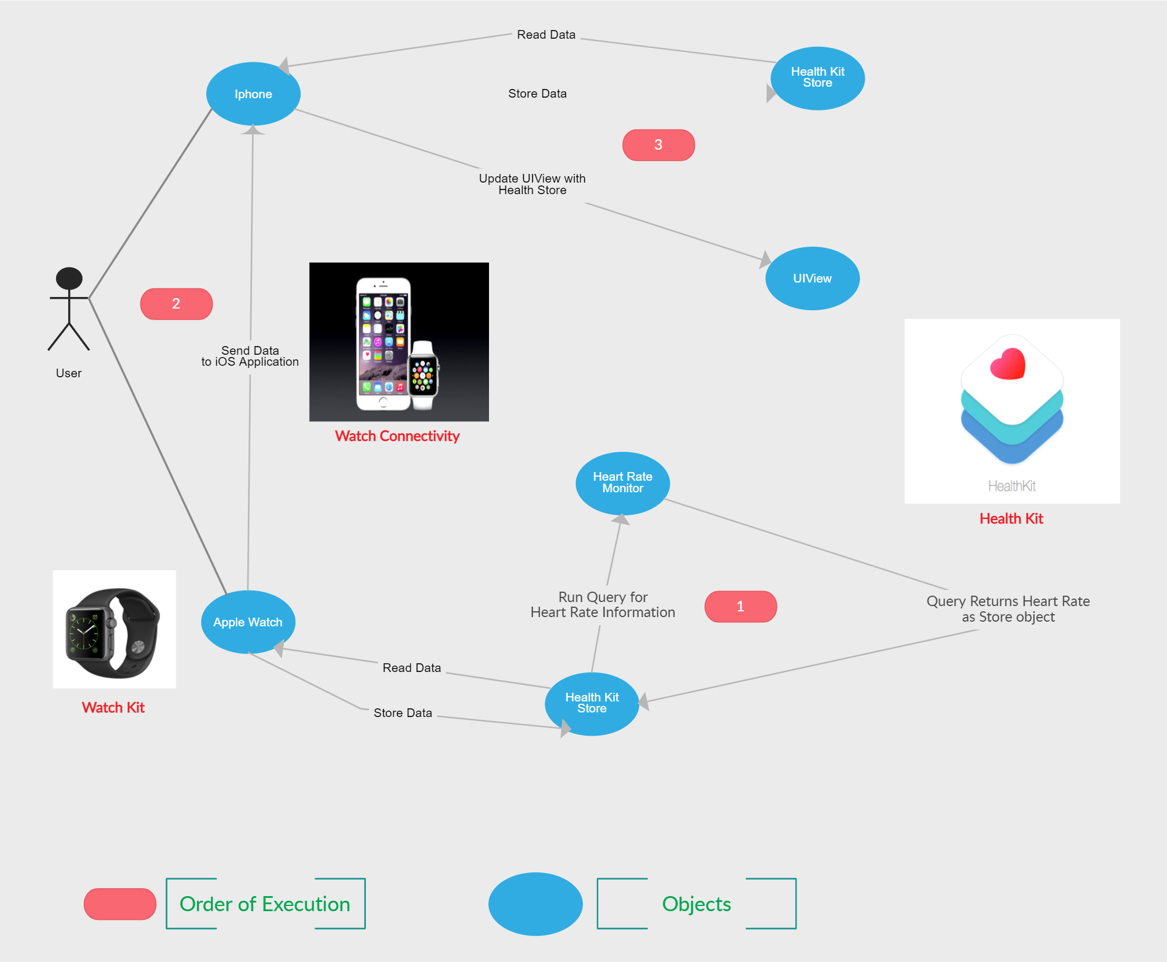

Figure 1: Heart Rate Monitor ( Use Case Diagram (UML))

* 1. **Watch Application API**

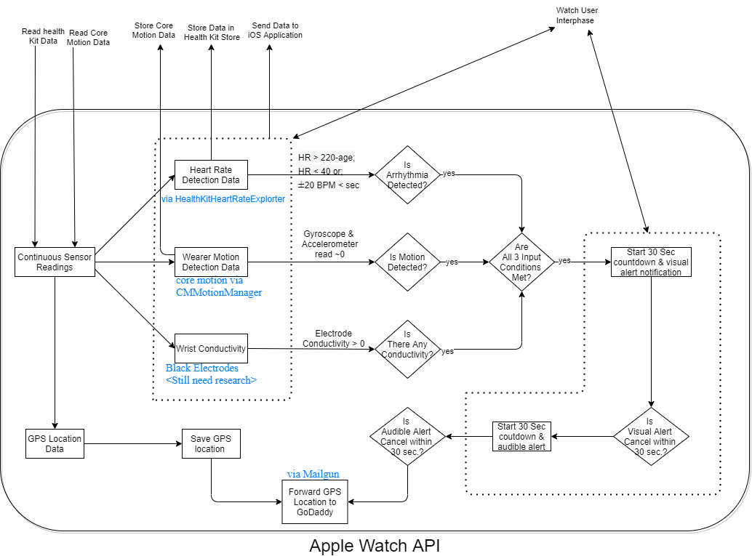

Figure 2: Apple Watch App API

* 1. **User Interfaces (Very Rough Sketch)**

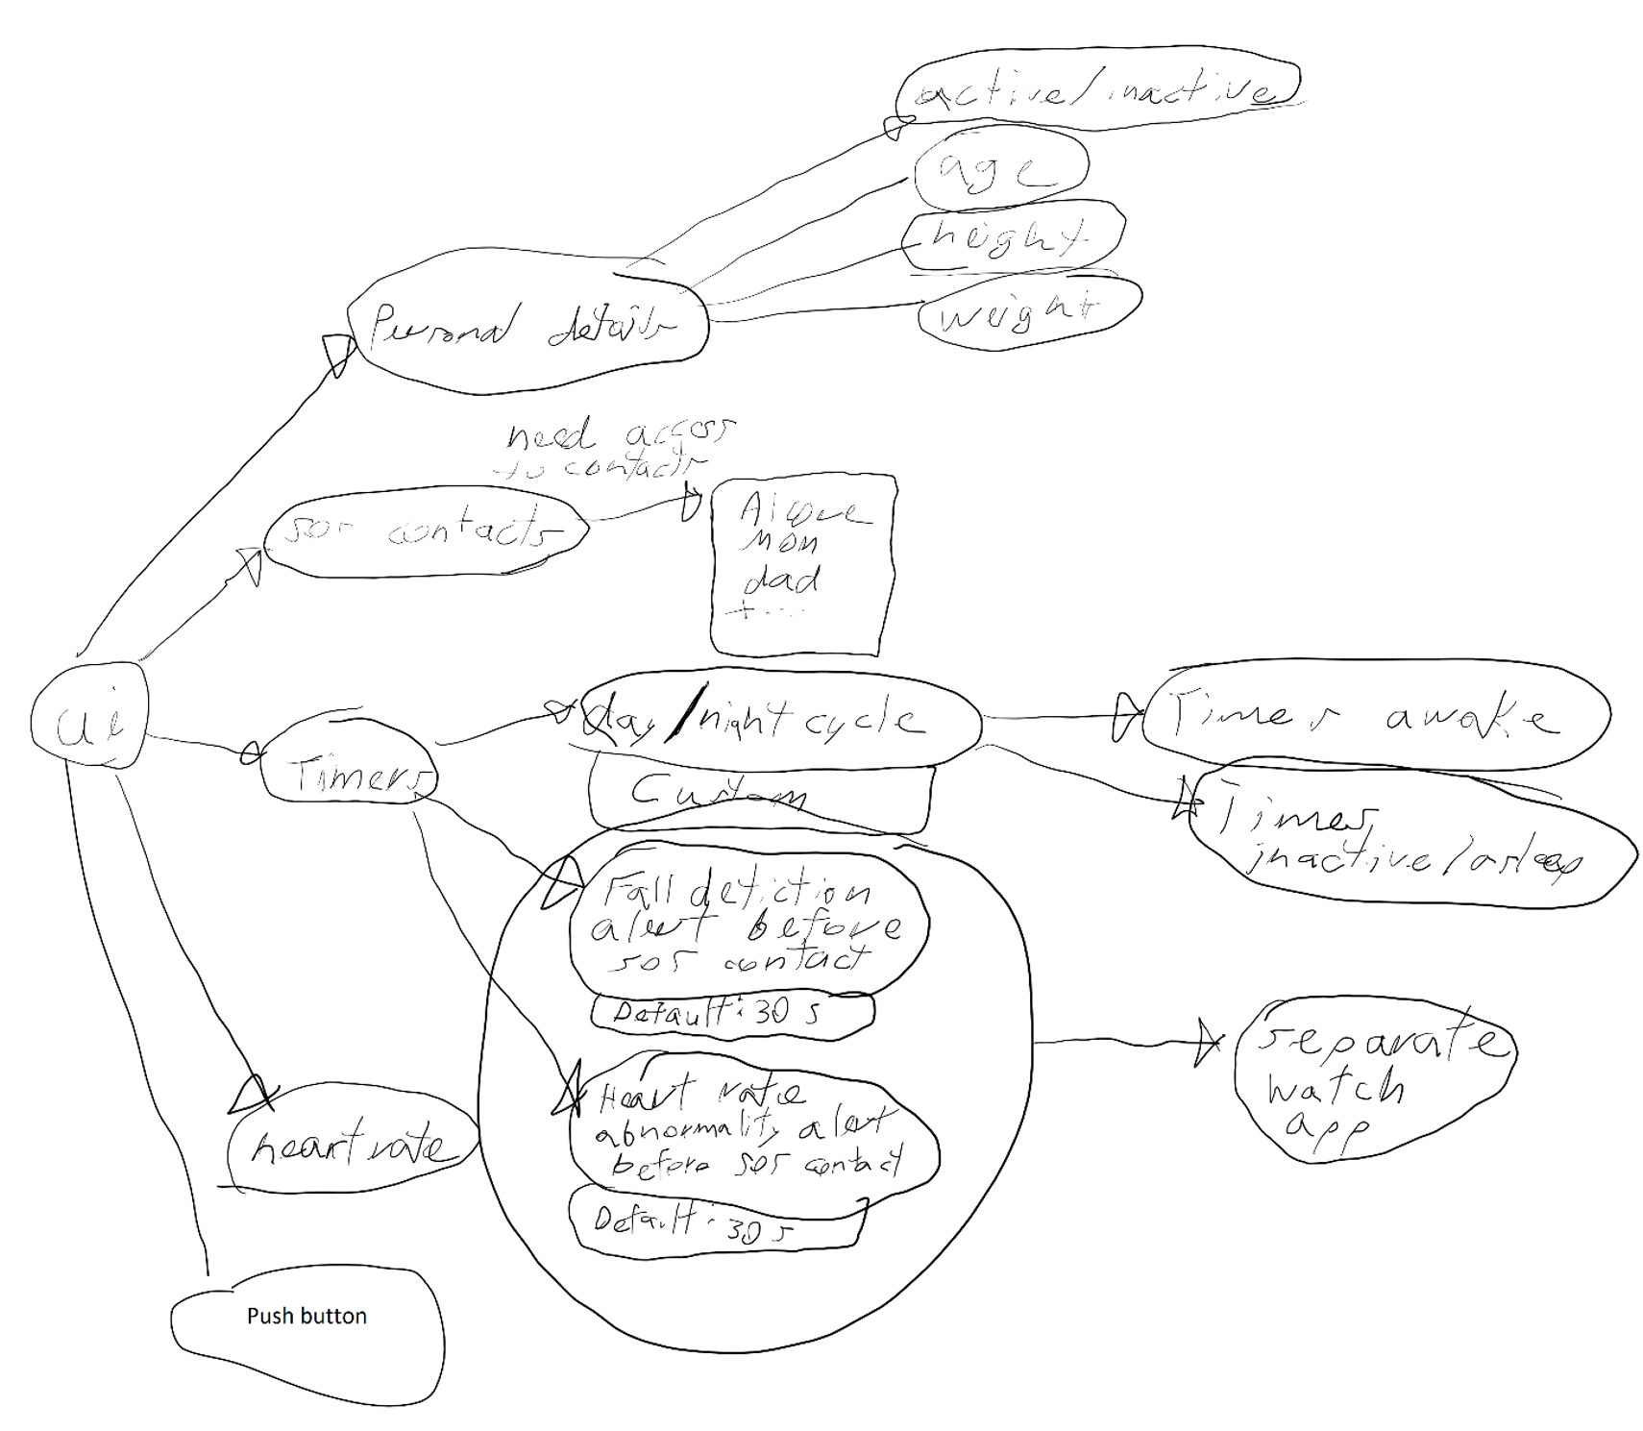

**NOTES**

**For Personal Notes. Not for Report**

**Health APP UI**

Set up Health Details

* First Name
* Last Name
* Data of Birth
* Sex
* Height
* Weight

Summary

* Health Checklist
  + Medical ID
    - Name <short answer>
    - Add date of birth <date>
    - Medical condition <short answer>
    - Medical Notes <short answer>
    - Allergies & Reactions <short answer>
    - Medications <short answer>
    - —————————————
    - add blood type <type>
    - organ donor <yes/no/register with donate life>
    - add weight <int>
    - add height <int>
    - add primary language <choices>
    - —————————————
    - add emergency contact
    - choose from contacts
  + Emergency SOS
    - set special button press
    - auto call when button press 5 times rapidly
    - countdown sound
    - **set up emergency contacts in Medical ID**
  + Back -> Profile
    - Health Details
      * First // Last // DoB // Sex // Blood // Skin Type // Wheelchair // Med affect HR
    - Medical ID
      * —>Medical ID
    - ——————Features———————
    - Health Checklist
      * —> back to Medical ID // Emergency SOS
    - Health Records
      * Access Records
        + <Use Location>
        + connect with Medical center // Hospitals
      * apps requesting access
      * research studies
      * Options
        + Share Data
        + Analytics Data
        + About Improve Health Records & Privacy
      * About Health Records and Privacy
    - Organ Donation
      * Sign up with Donate life
    - ——————Privacy———————
    - Apps
      * Apps requesting permission to health app
    - Research Studies
      * list of research studies allowed
    - Devices
    - Export all Health Data
* A bunch of non-medical health features like steps and movement analytics
* Get More Health:
  + Contribute health to research
  + set up sleep
    - set a sleep goal <# hrs / # hrs>
    - set schedule <M-F / Bedtime / Wakeup>
      * wake up alarm
      * sound & haptics of alarm
      * volume of alarm
      * snooze?
    - set up cycle tracking
    - register as an organ donor
    - Apps:
      * apps to add that can work with health app

Browse

* Go through health categories:
  + Activity
  + body measurements
  + cycle tracking
  + hearing
  + heart
  + mindfulness
  + mobility
  + nutrition
  + respiratory
  + sleep
  + symptoms
  + vitals

**B-Shield Features and API**

* <there are security requirements blocking the ability to make calls without user consent>
* Pairing devices via Bluetooth
  + B-shield pairs with Orbit Protect or Orbit Keys devices
  + Tap bar icon -> click “orbit Fob Setup” -> tap “Start Scan” -> beep confirms connection
* Lone Worker
  + Intended to provide protection to personnel who work alone
  + When activated, sends signal to central alarm station with GPS location every 5 min when singed out
  + With ask when time out gets close to expiring. Can end or reset.
    - If reset, only send signal with internet
  + To activate, indicate how long for
* Breadcrumbs
  + Lone worker without timer feature
  + Sends signal every 5 mins continuously till deactivated
* Pin drop
  + Manual GPS
* Man Down
  + Looks for movement every 7 minutes
  + If no movement, audible alert with be sent, wait 30 seconds, and if no movement is detected again and alert is not silence, 30 second countdown begins before contacting central station
* Declare Emergency
  + Sends GPS location to central station and calls central station
  + Press and hold until signal initiated to avoid false alarm
* Send Test Signal
* Info
* Emergency Number Setup

**What's in your Apple Watch**

Apple Watch Series 6

* Apple Watch Series 6 (GPS + Cellular) (Stainless Steel) and Apple Watch Series 6 (GPS + Cellular) (Hermès): stainless steel case, sapphire crystal, ceramic back
* Apple Watch Series 6 Edition: Titanium case, sapphire crystal, ceramic back
* Apple Watch Series 6 (GPS + Cellular) (Aluminum), Apple Watch Series 6 (GPS + Cellular) (Nike), and Apple Watch Series 6 (GPS): aluminum case, Ion-X glass, ceramic back

Apple Watch SE

* Apple Watch SE (GPS + Cellular) (Aluminum) and Apple Watch SE (GPS): aluminum case, Ion-X glass, ceramic back

Apple Watch Series 5

* Apple Watch Series 5 (GPS + Cellular) (Stainless Steel) and Apple Watch Series 5 (GPS + Cellular) (Hermès): stainless steel case, sapphire crystal, ceramic back
* Apple Watch Series 5 Edition: Titanium or ceramic case, sapphire crystal, ceramic back
* Apple Watch Series 5 (GPS + Cellular) (Aluminum), Apple Watch Series 5 (GPS + Cellular) (Nike), and Apple Watch Series 5 (GPS): aluminum case, Ion-X glass, ceramic back

Apple Watch Series 4

* Apple Watch Series 4 (GPS + Cellular) (Stainless Steel) and Apple Watch Series 4 (GPS + Cellular) (Hermès): stainless steel case, sapphire crystal, ceramic back
* Apple Watch Series 4 (GPS + Cellular) (Aluminum), Apple Watch Series 4 (GPS + Cellular) (Nike+), and Apple Watch Series 4 (GPS): aluminum case, Ion-X glass, ceramic back

Apple Watch Series 3

* Apple Watch Series 3 (GPS + Cellular) (Stainless Steel), Apple Watch Series 2 (Stainless Steel), and Apple Watch (1st generation) (Stainless Steel): 316L stainless steel case, sapphire crystal, ceramic back
* Apple Watch Series 3 Edition and Apple Watch Series 2 Edition: Ceramic case, sapphire crystal, ceramic back
* Apple Watch Series 3 (GPS + Cellular) (Aluminum) and Apple Watch Series 2 (Aluminum): 7000 series aluminum case, Ion-X glass, ceramic back

**API**

API on the Watch:

* Acceses Gyroscope & accelerometer via “core motion” to see if person is still
* Only needs to access GPS if triggered to do so

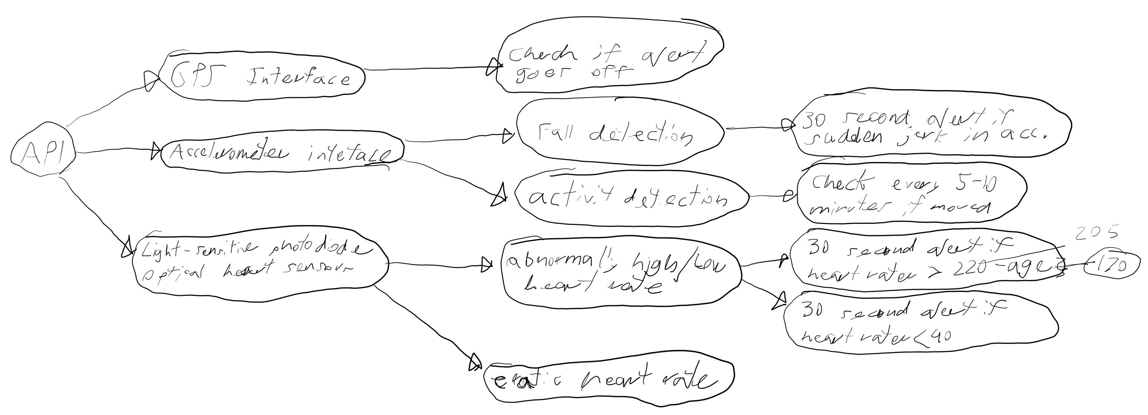

~~Maybe extra icon to be clicked (quick icon) for emergcy declaration~~

~~B-Shield press and hold until signal intiated to avoid false alarm, but ...~~

~~maybe ours does the opposite~~

always access heart rate, Gyroscope & accelerometer or takes advantages of other apps to avoid power consumption

toggle "Continuous Monitoring"

~~if heart rate low, high, or eratic, check Gyroscope & Accelerometer~~

~~---- if gyroscope & accelerometer are perfectly flat -- dont send alert~~

~~---- else ask user if they are ok~~

~~if core motion detects fall ask user if ok.~~

~~follow standard procedures of Apple fall detection~~

~~if toggle is off and fall detection detected, access heart rate.~~

~~if heart rate eratic -- contact wearer~~

CSC

~~app(Test flight) lets you share apps in beta while app is invisible on app store~~

~~me and Sam meet~~

~~check medical data for iphone that it requests (medical ID)~~

~~iphone 10~~

~~apple watch - 4~~

~~Sam Spohn --~~

~~figure out *icon thing* to upload to apple app store~~

~~go back through emails and draft requirements specification document and what type of screen/HCI's/UI needed~~

~~most importantly the functionality~~

~~early drafts run through mike before next week~~

~~Find out how watch already detects if its being worn - photoplethysmography~~

~~can phone tell heart rate? -- fingertip on your phone’s camera lens and the app will detect the colour change on your fingertip each time your heart beats.~~

~~use gyroscop as a inactive suppression~~

~~check if phone AND watch have fall detection -- only watch has fall detection~~

~~A fall is the condition when the total acceleration applied on the object equals the value of acceleration of gravity. We now know the accelerometer that provides Apple Watch the acceleration by which the device moves along the linear path. So, we will use this value to detect a fall in device.~~

~~check if there are any emergecy app that, if downloaded, you can lauch app which would initiate the emergency procedure~~

mailgun url - acts as relay to send automated emails as an sms text.

post to email you want and it emails for you. no sms atm

need credentials for godaddy. needs RSA keys to verify and DNS zone files. find out what Dr. O'Neal has to do to get those6

Go through files

proj4-folder

proj4 warch extension -

Some steps to go through

phone code - Proj4 -> contentview.swift

added a mailgun bridge.m

added a proj4-Bridging-Header.h -> allows includeing objective C code in swift code

Watch code - Proj4 WatchKit Extenison

contentview.swift

ExtensionDelegate.swift

Pods - allow package managment for IOS development

used to download mailgun and its dependencies

10/6/2020

get Github account and share with Sam so he can add me to the project on Github (Need to get myself developler privelages)

install test flight on Iphone 8

Flush out medical data app inforamtion pulling data and include in new document

Start flushing out Specification data document this week. API/UI figured out

document all the progress Sam has done

Include links and documents that help capture the progress. (some of the stuff already saved on Mac)

Icon development for app - Alcore A

look up b-shield

look through apps like fitness apps, the medical record app, and the b-shield app to get an idea of how other applications are using the sensors to accomplish tasks similar to what we have in mind.

Looking for UI inspiration From these apps might also be a good secondary rationale.

* ~~look up b-shield~~
* Icon development for app – Alcor A
* Start flushing out Specification data document this week. API/UI figured out
* Flush out medical data app information pulling data and include in new document
* document all the progress Sam has done
  + Go through all the websites I had pulled up and condense it into 1 document
  + Include links and documents that help capture the progress. (some of the stuff already saved on Mac)
* look through apps like fitness apps, the medical record app, and the b-shield app to get an idea of how other applications are using the sensors to accomplish tasks similar to what we have in mind.
  + Looking for UI inspiration From these apps might also be a good secondary rationale.
  + look through the B-Shield pdf in detail
* ~~look up b-shield~~
* Icon development for app – Alcor A
* ~~Flush out medical data app information pulling data and~~ include in new document
* look through apps like fitness apps, the ~~medical record app~~, and the ~~b-shield~~ app to get an idea of how other applications are using the sensors to accomplish tasks similar to what we have in mind.
  + Looking for UI inspiration From these apps might also be a good secondary rationale.
  + ~~look through the B-Shield pdf in detail~~

Make call but CallKit is reported not to work adequately; all them just ring on iPhone not on watch.

**11/10 Report**

~~Alternative ways to determine if smart watch is being worn other than photoplethysmography~~

~~Is there other ways to detect if the heart is being worn???~~

~~How does the watch know IMMEDIATELY when it is taken off?~~

Two different ways smart watches measure heart rate???

* Optical Sensors and Black Crystal Electrodes (section 2.4, pages 6&7)

For diagram, if gyroscope is moving, person not dead. Just can’t infer the inverse.

* section 2.4, pages 6&7

How long will the watch last in exercise mode?

* jump to section 2.7 Battery Life (page 9)

How does API work for smart watch?

* Starting point: <https://developer.apple.com/documentation/watchkit>
* The phone can only detect heart rate with special app that utilizes the phones camera a specific way. If you put your fingertip on your phone’s camera lens and the app will detect the colour change on your fingertip each time your heart beats. Is there some way we can use this?
* Go through all the websites I had pulled up and condense it into 1 document
* Include links and documents that help capture the progress. (some of the stuff already saved on Mac and documented in this)

Functions of use:

[applicationDidEnterBackground()](https://developer.apple.com/documentation/watchkit/wkextensiondelegate/1650865-applicationdidenterbackground) – saves any data you need to recreate your app’s current state because the system can purge sespeneded apps without warning

[performExpiringActivity(withReason:using:)](https://developer.apple.com/documentation/foundation/processinfo/1617030-performexpiringactivity) – Requests additional background execution time

<https://developer.apple.com/documentation/watchkit/working_with_the_watchos_app_life_cycle>

Figure 1: state changes in WatchOS app

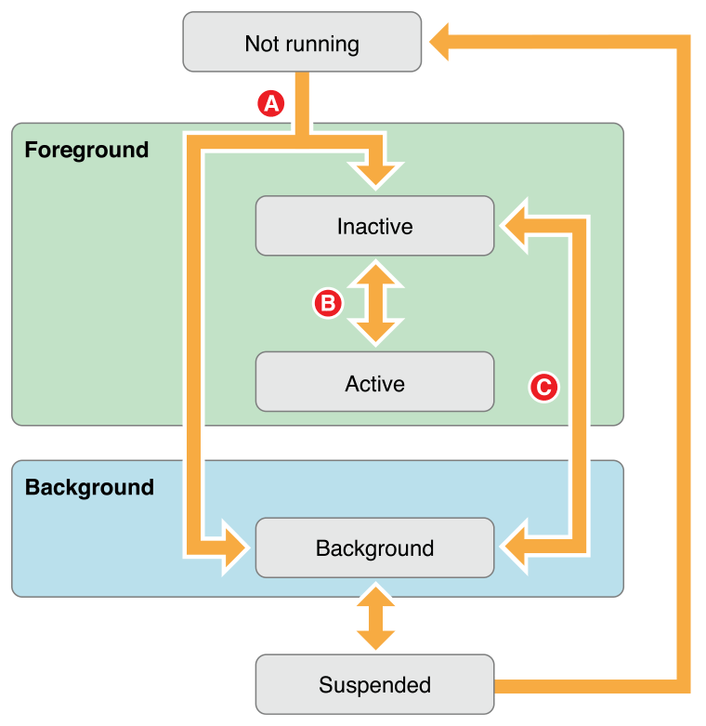

In Figure 1:

* **Transition A.** When transitioning from not running to either the inactive or background state, the system calls the extension delegate’s [applicationDidFinishLaunching()](https://developer.apple.com/documentation/watchkit/wkextensiondelegate/1628241-applicationdidfinishlaunching) method.
* **Transition B.** When transitioning between the inactive and active states, the system calls either the [applicationDidBecomeActive()](https://developer.apple.com/documentation/watchkit/wkextensiondelegate/1628185-applicationdidbecomeactive) or [applicationWillResignActive()](https://developer.apple.com/documentation/watchkit/wkextensiondelegate/1628206-applicationwillresignactive) method.
* **Transition C.** When transitioning between the background and inactive states, the system calls either the [applicationWillEnterForeground()](https://developer.apple.com/documentation/watchkit/wkextensiondelegate/1650868-applicationwillenterforeground) or [applicationDidEnterBackground()](https://developer.apple.com/documentation/watchkit/wkextensiondelegate/1650865-applicationdidenterbackground) method.

CloudKit requests use [URLSession](https://developer.apple.com/documentation/foundation/urlsession) to store data

If significant other or family has app, could we link the two to set off an alarm on the outside person

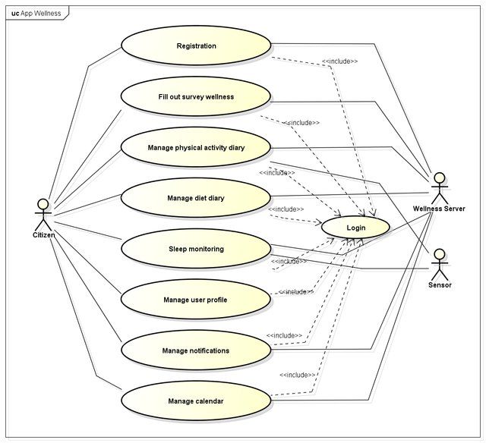

There might be built in libraires for wearer detection. Try to find something on this instead of trying to run with black electrodes

Last links and website of interest:

<https://journals.sagepub.com/doi/pdf/10.1177/0020294018813692>

<https://developer.apple.com/documentation/coremotion>

<https://developer.android.com/training/wearables/ui/wear-ui-library>

<https://medium.com/rosberryapps/wear-os-application-development-practical-aspects-a761019f7ec4>

<https://www.apple.com/healthcare/docs/site/Apple_Watch_Arrhythmia_Detection.pdf>

<https://developer.apple.com/documentation/healthkit>

<https://developer.apple.com/documentation/healthkit/about_the_healthkit_framework>

<https://developer.apple.com/documentation/watchkit>

<https://support.apple.com/en-us/HT204666>

<https://www.apple.com/healthcare/apple-watch/>